**Binary to Decimal**

Given a binary number as input, we need to write a program to convert the given binary number into an equivalent decimal number.

**Examples :**

**Input :** 111

**Output :** 7

**Input :** 1010

**Output :** 10

**Input:** 100001

**Output:** 33

The idea is to extract the digits of a given binary number starting from the rightmost digit and keep a variable dec_value. At the time of extracting digits from the binary number, multiply the digit with the proper base (Power of 2) and add it to the variable dec_value. In the end, the variable dec_value will store the required decimal number.  
For Example:

If the binary number is 111.

dec_value = 1*(2^2) + 1*(2^1) + 1*(2^0) = 7

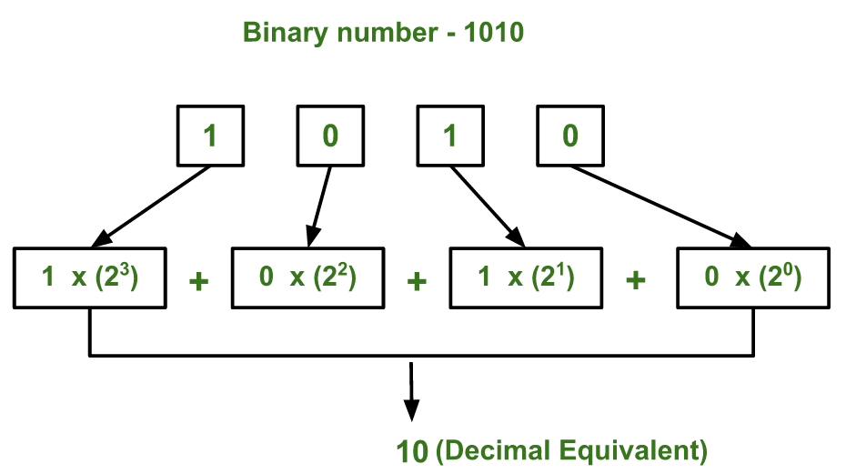

C++

#include<iostream>

using namespace std;

int main()

{

int n, val = 0 , base = 1;

cin >> n;

while(n > 0)

{

int lastDigit = n%10;

val += (lastDigit*base);

n /= 10;

base *= 2;

}

cout << val;

return 0;

}

`**INPUT :**

**1010**

**OUTPUT :**

**10**